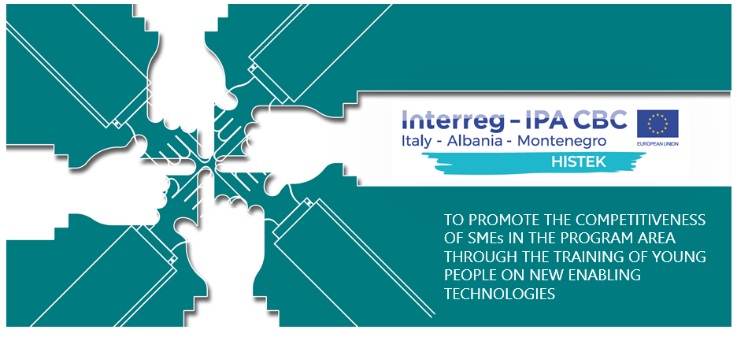

HISTEK FINAL CONFERENCE AGENDA

10:00 – 10:15 | Welcoming Speeches  - Dragisa DAMJANOVIC  Project Manager Ministry of Education  - Chiara CAMPANILE  JS Officer
10:15 – 10:40 | WPT1 Results: how we analysed the needs of the three Countries  - Cosmo ALBERTINI  Project Manager Chamber of Commerce of Bari
10:40 – 11:05 | WPT2 Results: the proposal of HISTEK cross-border curriculum  - Roberto VINGIANI  Project Coordinator ITS A. Cuccovillo
11:05 – 11:30 | The importance of collaboration in KETs: the experience of HISTEK in the cooperation among different actors for the future of the educational system  - Dragisa DAMJANOVIC  Project Manager Ministry of Education
11:30 – 12:00 | Round Table: the impact of HISTEK project in Italy, Albania and Montenegro  - Dragisa DAMJANOVIC  Project Manager Ministry of Education  - Stefan JOVANOVIĆ  Project Team member, Chamber of Economy of Montenegro  - Annamaria PATELLA  Project Manager ITS A. Cuccovillo  - Cosmo ALBERTINI  Project Manager Chamber of Commerce of Bari  - Azeta TARTARAJ  Project Manager Faculty Aleksandër Moisiu  - Alma KORDONI  Project Manager Chamber of Commerce of Tirana

Moderator: Dragisa DAMJANOVIC

Link to the online event: FINAL CONFERENCE – 29 JUNE 2021
