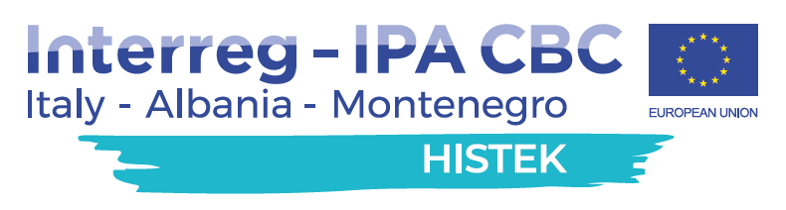

TO PROMOTE THE COMPETITIVENESS OF SMEs IN THE PROGRAM AREA THROUGH THE TRAINING OF YOUNG PEOPLE ON NEW ENABLING TECHNOLOGIES

HISTEK FINAL CONFERENCE

29 JUNE 2021  Tuesday - ore 10:00  ONLINE MEETING  Link to the event:  FINAL CONFERENCE | The project partners are pleased to invite you to participate in the Final Conference of the HISTEK project, funded by the Interreg IPA CBC Italy-Albania-Montenegro Programme and targeted at the joint design between the 3 countries of a new short-cycle CB path, aimed at DEVELOPING AND ENHANCING the cross-border educational system focusing on new technological skills (KETs), to support the innovation processes of SMEs at the Cross Border level  During the event, the main results achieved by the HISTEK Consortium will be presented.  Speakers:  - Dragisa DAMJANOVIC  Project Manager Ministry of Education  - Stefan JOVANOVIC  Project Team member, Chamber of Economy of Montenegro  - Annamaria PATELLA  Project Manager ITS A. Cuccovillo  - Cosmo ALBERTINI  Project Manager Chamber of Commerce of Bari  - Azeta TARTARAJ  Project Manager Faculty Aleksandër Moisiu  - Alma KORDONI  Project Manager Chamber of Commerce of Tirana
